Top 10 Mistakes Yoga Teachers Make

Most yoga teachers are nice people but can they teach?
- Not teaching to their audience. Always teach to the Beginner 1st. Downward Dog is not a Beginners pose. It is an inversion.
- Not offering modifications & precautions. Our body is not every body. Each student in the class should have a place to be and or go. Yoga is not a spectator sport.
- Closing their eyes &/or practicing with the students. We are being paid to teach, not to practice.
- Talking is not teaching. Guide students safely into postures; refine details while in the postures and safely guide them out. Use direct, concise, language. “Come in to Downward Dog”, “switch sides” is not teaching.
- Not teaching warm-ups to prepare the body for the postures. Passive & supportive stretches prepare the body for the poses i.e. Leg Cradle before Pigeon (not after)
- Demonstrating postures when not necessary OR not demonstrating postures when necessary. Demos (stop & watch me) are used for safety and to enhance a class. They are not offered in lieu of teaching.
- Preaching instead of teaching. Philosophy (like demos) should enhance a class not take the place of instruction.
- Skipping the foundational postures; how to sit, how to stand. i.e. Mountain must to be taught to move into Tree or any balancing pose.
- Ending and/or starting the class late. Respect the students.
- Not attending classes. Practice what we teach. We become teachers because we love doing yoga. Good teachers are forever students. A certificate does not change this.
Bonus #11 - Sitting with poor posture. Lead by example!
It is our job/responsibility is to provide a SAFE place for people to find themselves.
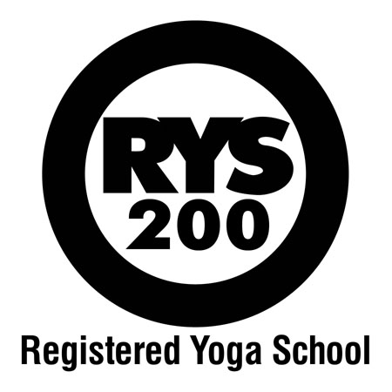
Breathe Yoga School ~ Where we train you how to teach!
www.breathyoga.ca

